**Know Your Future English & Spanish Poster Presentation Printing Instructions**

Due to the large file size of the computer documents to achieve maximum quality, and the upload file size limitations of the hosting company of our website, we could not post all poster documents on our website for free use. Instead, we decided to make available on a dual layer DVD a set of enlarged Know Your Future small booklet tract pages that can be printed on inexpensive Dollar Tree Store 22" x 28" poster board using a wide format inkjet printer. The sixteen pages can be laminated to keep them clean. The posters can be placed on a light weight easel for a gospel for a group presentation like I did at the Santa Barbara County Fair in league with a local Spanish / English church that rents a booth each year. One might also consider all sixteen pages laid out on just two posters printed individually, taped end to end, laminated, and placed in a large window. The laminated size is 22.5" high by 56.5" wide.

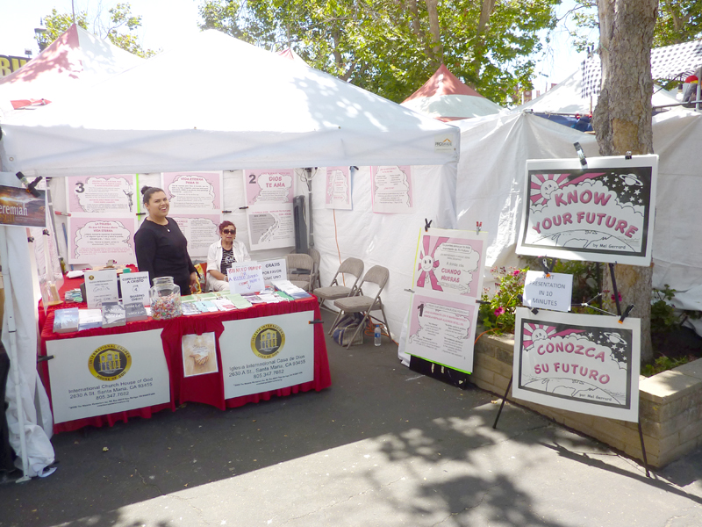

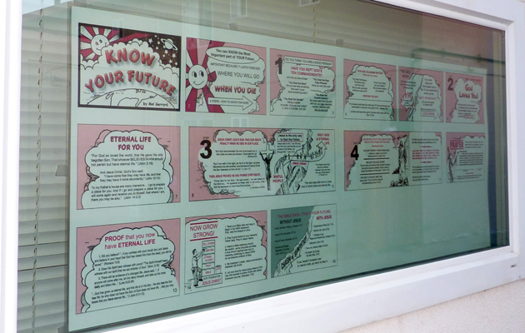

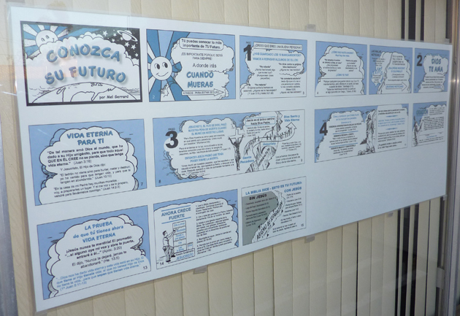

Note: The poster easel display was too large a file for a single Dual Layer DVD. It would have to be put on a 32 gigabyte thumb drive or in parts on multiple DVDs. However, the read order window display will fit on a DVD; and, the press quality PDF English and Spanish read order documents are about 13 megabytes each and can be put on a DVD and posted on our website. They also have a text field box at the bottom of the second page where a ministry's contact information can be typed in 18 point type size before printing page two. Right clicking the mouse in this text box also allows rich text formatting such as bold and italic. The English and Spanish read order computer documents will soon be downloadable from our website, www.tracts4u.com.

1) I used a 2006 Epson Stylus Pro 7600 which an print 24" x 59". I left a margin in the computer document of .5" top and bottom, and .625" on the sides. Older printers require a 5/8" margin at the tail end when not printing in full bleed mode. Also, this printer uses a pigmented ink set which may be more fade resistant the posters are exposed to prolonged sunlight.

2) Print on the non shinny side of the paper at 760 dpi quality. Dry the surface with a hair dryer if laminating immediately after printing. Join posters together with packaging tape on the back only.

3) The above pictured projects used two colors from the Pantone Matching System. For a laser printer or inkjet to simulate these solid colors normally used on a printing press, the printer mixes its six colors to simulate the pantone color. The result is a mottled look. For a smoother look, one should make a chart document on the computer using one of the solid non mixed colors that come with the inkjet printer. In our case, one would substitute magenta for the PMS purple used on the press, and cyan for the PMS 293 blue used on the press in making the Spanish *Know Your Future* booklet.

3) For the poster presentation on an easel (one tract booklet page per poster board), I noticed that, in the booklet, pages 8 & 9, and 10 & 11 the graphics are meant to connect as a set. Therefore I added two additional *double wide* pages to the computer document being printed from. In this case, the matching pages are taped together on the back and printed as the longer 22" by 56" sheet. There will be printing in the joint area, and one will have to support that area as the second poster board enters the printer. Laminating the two posters as a set will make it easier to hold them on an easel. An easel like the one pictured, has an optional top bar clamp to help keep the poster board flat.

4) In the case of the read order tract on two posters for a window display, one prints the two poster pages separately on two sheets, then tapes them together end to end on the back before laminationg the two together.

5) HIS Print Media Ministries is willing to print and mail these tract displays at a price. We are also willing to help design similar presentations of other tracts. To do this, we prefer to work from a computer document with high quality graphics (artwork). The artwork in the above pictured enlargements was poor quality, but turned out better than expected. Our printer has an option for *optimizing* graphics. Vector based graphics are harder to make, but can be enlarged without a loss of quality.

We hope Christians with a heart for Evangelism will utilize our creations which took hours to make. For additional help, contact David at 1-805-452-5150, or e-mail: info@tracts4u.com. We would like to hear from you about your accomplishments with our materials.

Evangelist Dr. David Hupp at HIS Print Media Ministries